A validated forecasting model for optimizing dispatch schedules of PV - battery system in grid-connected apartment buildings
Author links open overlay panelLinda Lundmark ª ^{b}
, Farzin Golzar ª, Rafael Guedez ª, Majid Astaneh ^{b}
Show moreAdd to Mendeley
Share
Cite
https://doi.org/10.1016/j.apenergy.2025.127123
Get rights and content
Under a Creative Commons license
Open access

Highlights
- •
A robust, reusable day-ahead optimized dispatch schedule is developed and validated using the real-life setup of KTH Live-in Lab.
- •
A comprehensive techno-economic analysis of the system's potential is conducted over the lifespan of the coupled PV system.
- •
The potential and limitations of the Battery Energy Storage System (BESS) are analyzed over the PV installation's lifecycle.
- •
Discussion on the need for further study on the interaction between peak power billing and flexible RTP energy pricing.

Abstract
The escalating emissions of greenhouse gases have emerged as the primary driver of global warming. Cities have been found responsible for 70 % of global CO2 emissions. This brings high potential for lowering greenhouse gas emission by introducing innovative technologies in urban environments. One promising technology is Photovoltaics (PV) coupled with energy storage systems (ESS). In this paper, the deployment, integration, and operation of ESS coupled PV is being investigated. This involves installing a real-life PV-ESS system in the KTH Live-In-Lab. This paper focuses on the optimization of battery operations and prepares the framework for an automated operation of the real-life battery installed in the KTH Live-in-Lab. The focus centers on achieving two separate objective functions: minimizing costs and maximizing self-consumption. These goals are pursued through the application of linear optimization, day-ahead forecasting, and real-time control.
The results compare the performance of change in solar power self-consumption and cost for each year. Where the ‘Base case’ scenario served as a benchmark with a yearly cost of 210,078 SEK in 2022 and self-consumption of 71.86 %. The cost optimization considers two different scenarios where monthly peak demand billing is considered or disregarded. Without considering the monthly peak power billing, costs drop by 32.2 % and self-consumption increases significantly to 96 %. Considering power charges reduce costs by 14 % and self-consumption was slightly improved to 98 % compared to the base-case. The optimization for maximizing self-consumption shows an improvement in costs of 3 % and achieves 100 % self-consumption. The forecasting-optimization framework introduced in this study is a valuable decision support tool, aiding stakeholders in making informed choices about balancing costs and self-consumption for PV systems integrated with battery energy storage systems in grid-connected apartment buildings. The tool is adaptable and can be trained for different sites and is capable of handling different cost structures to evaluate the full energy trading landscape. The findings show that the battery dispatch strategies must be dynamic regardless of the season. This is due to the interplay between energy availability, market prices, and grid interactions to optimize performance and cost. They also highlight that for larger grid connections (above 80 A) a more flexible power billing structure would improve the financial viability of PV-BESS systems for the end user.

Keywords
Renewable energy resources
Integrated battery- photovoltaics
Machine learning
Linear optimization
BESS aging
Day ahead forecasting

Nomenclature
Abbreviations
ANN
Artificial Neural Network
BESS
Battery energy storage system
ESS
Energy storage system
GCRS
Grid connected residential sector
LCOS
Levelized cost of storage
MLP
Multilayer perceptron
PV
Photovoltaics
RTP
Real time price
SEK
Swedish Krona
SMHI
Swedish metrological and hydrological institute
SOC
State of charge
TOU
Time of use

1. Introduction
The emissions of greenhouse gases are a primary driver for global warming and the effects that this has on climate change. Cities play a significant role in this problem as they are responsible for 70 % of global CO2 emissions [1] [2],. Therefore, there is a high potential for emissions reduction by improving the energy footprint of urban built environments. Since cities are very dynamic and have dense ecosystems, they offer numerous options that can be developed to achieve the climate targets. Photovoltaics (PV) systems installed on buildings present a promising solution for green energy generation in urban settings [3]. This approach offers several advantages such as having electricity generation near consumption, which minimizes transmission losses. Not requiring extra land, making them well-suited for deployment in densely populated areas.
Although solar PV installations are increasing in Sweden, they contribute less than 2 % to the country's energy supply, falling short of the 2040 target [4]. Promoting solutions involving PV-ESS is crucial for enhancing solar installation viability in residential buildings, requiring exploration of various storage asset monetization methods. To meet the 2040 goals, large efforts are needed to bridge the gap in solar cell adoption. This emphasizes the importance of new business models and technical innovations. [5].
To develop a dynamic pricing model, Sweden's household electricity tariffs, comprising energy costs (50 %), trading costs (25 %), and network fees (25 %), must be understood. Grid fees include fixed, monthly power, and transmission charges, with additional monthly and high load fees applied in winter and for high-power connections. This breakdown helps consumers optimize power use strategies. Monthly power and high load fees are peak-demand charges based on the highest power drawn in any hour of the month. These fees incentivize consumers to distribute electricity evenly, promoting energy efficiency through load management systems.
The use of peak demand fees is a method to encourage a stable load profile. As the future energy system is relying on a high percentage of intermittent energy it requires a load and/or energy storage solutions to be able to rapidly adapt towards the fluctuations in energy production. The energy trading market is adapting towards this need to incentivize load flexibility. For example, by offering hourly real-time pricing schemes. For larger energy consumers a conflict arises as the gain achieved by increasing consumption during high energy generation and low energy prices must be balanced to the peak demand billing schemes. In this study the impact of this conflict is investigated by optimizing the cost minimization using a BESS. Comparing the impact of the financial potential of a system operating with the consideration of monthly power- and high load fees. With the financial potential of the system that only considers the pricing signals of the real time price signals from the energy market.
Existing literature predominantly focuses on the techno– economical aspects of PV systems, there is a shortage of validated models on battery integration and optimal planning. Therefore, there is a need for efficient planning processes to maximize the benefits of PV-ESS and address grid-related challenges in residential settings. Most of the studies that have been published on the topic have been done considering flat or time of use (TOU) electricity prices. However, considering the advancement of smart grid facilities there is a need to perform optimal planning considering real time pricing and demand response as stated in recent literature reviews [6,7].Examples of recent studies considering optimization of operation considering TOU are: In [8] a convex optimization strategy is deployed for PV-BESS sizing and operation. It focuses on system sizing rather than detailed operation strategies. In [9] the authors investigates approaches to improve cost effectiveness for single family homes in California considering the TOU value of energy storage. Providing investment insight into PV-BESS in net zero homes. In [10] a multi-objective optimization of operation of grid connected PV-BESS in energy sharing community is performed, also this one considering TOU- tariff structures. The study also highlights that future research needs to build techniques for predicting the load of buildings.
In [11] the authors develop a deep-learning-based multi-timescale integrated optimization framework for DER-assisted building electrification, achieving operational carbon emission reduction while minimizing total costs. This is done by incorporating a DNN model to approximate computationally expensive control optimization, the framework efficiently optimizes both design and control variables. Simulated case studies on a single-family home deploying a TOU tariff structure demonstrate its effectiveness in reducing grid electricity demand and costs, highlighting the importance of DERs even in future grid scenarios. The study highlights future research should explore scalability to diverse building types and validated models on real-world applications.
[12] presents a Model Predictive Control (MPC)-based energy management framework to optimize building electrification and Distributed Energy Resource (DER) integration, addressing the evolving challenges of decarbonization. By dynamically responding to real-time grid signals, the framework significantly reduces electricity costs and carbon emissions while enhancing grid flexibility through peak load shifting. It effectively integrates solar PV, energy storage, and EV-to-building interaction, achieving cost savings and peak load shifting performing better compared to conventional control. The approach is computationally efficient and can be seamlessly integrated into existing Building Energy Management Systems. However, its applicability was tested in simulations with a single-family home, requiring further research to validate performance in real-world settings, adapt to various building types, incorporate occupant behaviors, and refine optimization techniques for broader deployment.
Some recent studies that do consider real time pricing for residential PV-ESS applications are [13,14]. In [13] the focus is on cost minimization while ensuring fair usage of shared PV and ESS resources among residents. The study integrates RTP into its energy management framework. This integration is crucial for minimizing costs while ensuring fairness in resource allocation. The study highlights that current approaches primarily focus on managing uncertainties related to PV production. It concludes that future research should extend these methods to include uncertainties associated with residential load demand and energy transaction prices. The study suggests that addressing these broader uncertainties will lead to more robust and resilient energy management systems.
In [14] the optimal capacity sizing of residential microgrids that integrate solar photovoltaic (PV) systems, wind turbines, and BESS under the influence of real-time electricity pricing (RTP). The study suggests future research should focus on investigating the optimal sizing of microgrids with new energy management strategies that can adapt to forecasted electricity prices. This would involve exploring practical guidelines for customers to select the best electricity pricing mechanism and appropriately size residential micro grids based on the specific load demand profiles of individual households. To enable this forecasting models which consider RTP, load and generation are required. The study also highlights that real life pricing schemes need to be studied and recommendations to end users need to be specified accordingly.
In [15] the authors highlight how deep reinforcement learning (DRL) shows superior result in comparison to rule based control for PV-BESS. In the study DRL is employed to predict the dispatch schedule, considering weather data and historical pricing signals to train the model to predict hourly pricing and power generation to optimize the battery charge and discharge patterns. In the study it is highlighted that the uncertainty in energy pricing is intensifying as renewable energy takes a larger share of the energy markets. This is addressed by including one year of historical data for pricing as a data set for training their model to predict the hourly cost per kWh the coming day. The study focuses on PV-self consumption as selling to the grid is limited due to regulations.
This study addresses gaps identified in the literature by developing a model directly integrated into the day-ahead market, generating optimized control patterns for the next 24 h that respond to real-time market prices (RTP), forecasted PV production, and load forecasts. The resulting model provides flexible daily control, improving the system's performance within the real-time market and addressing the research gap for PV-ESS within the Grid-Connected Renewable System (GCRS). This optimized dispatch schedule is designed as a robust model capable of handling various billing structures, such as RTP and peak demand fees. It is based on a real-life system installed in the KTH Live-In Lab, where it is validated in a live setting. The study also provides a holistic analysis, encompassing load and PV-production modeling, RTP billing structure, and system degradation, to evaluate the potential and limitations of Battery Energy Storage Systems (BESS) over the PV installation's lifespan.
To the best of our knowledge no earlier studies have analyzed the impact that monthly and seasonal peak demand billing will have on the financial feasibility of residential PV-ESS. Therefore in this study the models are using information from the billing contracts negotiated for the live-in lab and coupled with the day ahead spot pricing from Nordpool. [16] This results in a complete analysis of the integration of the system into the Swedish energy market. Evaluating the possibilities and gird interaction when operating according to a real time pricing scheme, while simultaneously investigating conflicting billing structures which may limit the full utilization of the financial potential of the system. Which directly answers to the need of studying real life energy trading as highlighted in [14]. The interaction with live pricing also enables the model to adapt to variations of price not only occurring based on seasonal variation but also yearly variation caused by change in the energy market and thus adding as a complement for models predicting price based on historical. To address the uncertainties highlighted in [13] the model developed in this paper uses ANN to predict the load and interacts with the live pricing signals provided by the grid provider to generate a powerful tool which can adapt to the prices on the market in real time. Finally, the results from the model are validated and analyzed using real life data from a live set up in the kth live in lab. Proving the framework feasibility also on real life application. This is something that has been highlighted as a research gap in previous work. To give a better insight into the relevance of this study, the studies sharing the largest similarities with this study are presented in Table 1.
Table 1. Taxonomy table over previous studies with similar scope.
Empty Cell | Objective of study | Tariff | Spot price arbitrage | Peak power billing | frame-work | Bess aging | data set | validated on real life setup | Load type
[10] | Scaling and rule-based control | TOU | – | – | Multi-obj. Opt. | – | Sim. | – | Community
[9] | Cost evaluation | TOU | – | – | BE opt | – | sim. | – | Single household
[12] | Optimized live control | TOU | – | – | MPC | – | sim. | – | Single household
[11] | predictive day ahead control and scaling | TOU | – | – | DNN | – | sim. | – | Single household
[13] | Optimized live control | RTE | x | – | MILP | – | sim. | – | community
[15] | predictive day ahead control | RTE | (x) | – | DRL | – | real | – | commercial
[14] | System Scaling | RTE | x | – | PSO | x | real | – | Appartment building
This study | predictive day ahead control | RTE | x | x | ANN | x | real | x | Appartment building

1.1. Case study
The research project, “Integrated turnkey solutions for PV-ESS” the deployment, integration, and operation of photovoltaics (PV) coupled with an energy storage system (ESS) is being investigated [17]. The project is a collaboration between KTH [18], Northvolt [19], and Einar Mattson [20]. The project is funded by the Swedish Energy Agency. The project aims to identify the turnkey solution for integrating PV-ESS in Swedish buildings. This is accomplished through a two-fold approach where techno-economic analysis is studied, and a real-life system is showcased in the KTH Live-In lab. [21] The project aims to improve access to solar electricity in the Swedish housing sector by identifying sustainable PV-ESS business models and developing innovative solutions to enhance system flexibility and resilience [17].

1.1.1. The physical set up
The model is developed to be integrated into the test bed at KTH live in lab. A research facility at the KTH Royal Institute of Technology in Stockholm, Sweden. Here innovative technologies are integrated into a real-life environment. This enables collaboration between industry, researchers, and residents and enables testing, evaluation and development of sustainable solutions. [21] In this research project a 186 kWh BESS has been integrated with the building and its preexisting roof mounted PV. To understand the topology of the system the single line diagram of the system is displayed in Fig. 1. Technical information on the BESS is shown in Table 2. The energy flows analyzed and simulated in this study are displayed in the flow chart in Fig. 2.
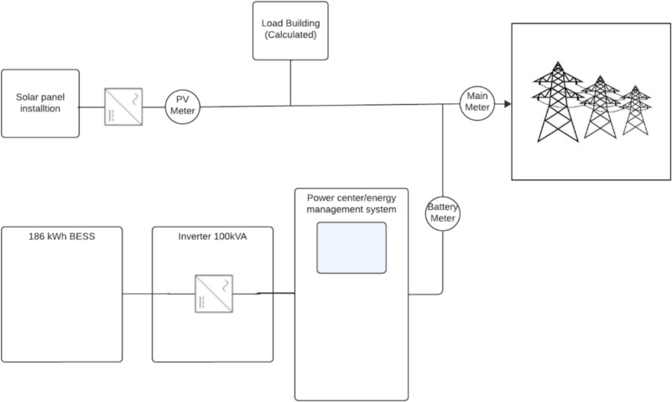
- Download: Download high-res image (178KB)
- Download: Download full-size image
Fig. 1. Single line diagram displaying the main components of the BESS integration into the building and its solar panels.
Table 2. Technical specification battery cabinet.
BESS specification | Empty Cell
BESS Capacity | 186 kWh
MAX depth of discharge (DOD) | 95 %
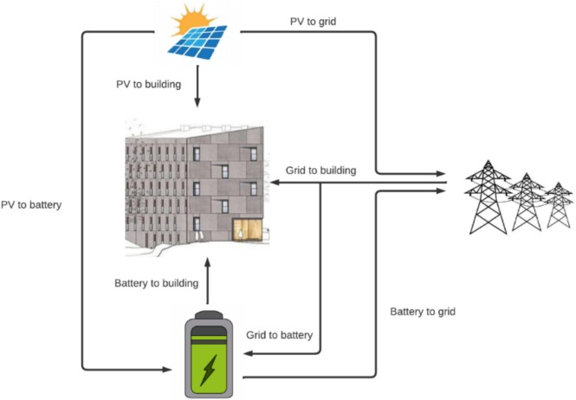
- Download: Download high-res image (178KB)
- Download: Download full-size image
Fig. 2. Flow chart showing the energy flow between the building, the PV-panels, and the grid.
The BESS is integrated with the already existing PV installations on the roof of the live-in lab the total installed power of the PV system is 76.4 kW. The PV is integrated to the buildings AC grid using its own inverter. Technical information on the PV system can be found in Table 3.
Table 3. Rooftop solar PV system specification for KTH live in lab [22].
PV Specification | Empty Cell
Total installed capacity | 76.4 kW
Total number of PV modules | 228 nos.
Electricity generation in 2020 | 68.58 MWh
To protect sensitive information provided by the partners of the project, the investment cost disclosed in this paper is based on publicly available sources for this kind of system and can be found in Table 4. [23]
Table 4. Investment cost BESS *based on publicly available data and differs from the investment made in the project to protect sensitive information provided by project stakeholders.
Investment cost BESS | Cost per kW/kWh [23] | Installed capacity | total investment cost
Battery cabinet | 211USD/kWh* | 186 | 39,246
Inverter | 97USD/kW* | 100 | 9700
Total |  |  | 48,946

1.1.2. Meter data
Having the system integrated into the live-in lab gives the project access to the historical and live data from the building which is a vital part of developing and training the models. All meters are updated every 10 s and logged onto a dedicated server. By using the information from these meters, the power flows in the building can be calculated.

1.1.2.1. Solar production from meter data
To accurately develop, train, and validate predictions of generated PV energy, historical data from the PV meter (as shown in Table 5) was collected. This data reflects the actual PV production from the installation detailed in Table 3.
Table 5. Meter data that has been used to develop and train the model.
Name of measurement | Unit | Name of meter
Energy Main meter | Wh | Main meter
Power Main meter | W | Main meter
Energy Solar panels | Wh | PV meter
Power Solar panels | W | PV meter
Energy Battery storage | kWh | Battery meter
Power Battery storage | W | Battery meter
Total Exported Energy Battery storage | Wh | Battery meter
Total Exported Energy Main meter | Wh | Battery meter

1.1.2.2. Load from meter data
To develop the load forecasting model, meter values from all three meters described in Table 4 were utilized. In this model, the load is based solely on the household electricity consumption of the apartment. It is calculated by subtracting the power values of the PV meter and battery meter from those of the main meter.

1.1.3. Billing structure for KTH live in lab
To understand how to best develop the cost model for dynamic pricing the full tariff structure needs to be studied. In Sweden, the tariff structure for household electricity costs comprises three main components: energy cost, electricity trading cost, and electricity network fee [22]. Understanding the breakdown of these costs is crucial for consumers to optimize their power consumption strategies. The energy cost component, constituting 50 % of the total expense, encompasses various charges such as taxes and fees. The trading cost, accounting for 25 %, is allocated to the power trading firm, while the remaining 25 % covers the electricity network fee, encompassing grid maintenance and distribution. [22] The electricity grid price consists of a fixed fee (SEK/month), a monthly power fee (SEK/kW, per month), a transmission fee (SEK/kWh) and if the power connection exceeds 80 A a monthly power fee applies. [24] In addition to the monthly power fee there is a high load fee added during the winter months (November–March).
The monthly power- and high load fees are peak demand billing tools that are based on the highest amount of power (measured in kilowatts, kW) that a household or business draws from the grid during any given hour in a month. The purpose of this kind of fee is to it incentivize the consumers to manage and distribute their consumption of electricity evenly throughout the day and the month rather than concentrating on certain peaks. This structure encourages the consumer to improve energy efficiency using load managing systems.
The model considers the full cost structure for energy and power trading based on the billing agreement that is set up for the lab which is shown in Table 6.
Table 6. Bill breaks down for KTH live-in lab * where the power effect is considering both monthly peak power and high load fee.
Fee name | Price/unit | Definition
Average spot price 2022 SEK/kWh | 1.07 | Average spot price per kWh in 2022 this price will vary on an hourly basis as this project utilizes RTP
Fixed gird fee SEK/month | 2600 | Fixed grid fee, fee related to the cost of being connected to the grid
Grid fee flexible SEK/kWh | 0.09 | A flexible grid fee is added on each kWh to charge for the load added to the grid
Monthly peak power SEK/kW peak* | 67 | Monthly peak power bill, billed for the highest power hour in the
High load fee SEK/kW peak* | 70 | Additional peak power fee added on top of monthly power bill during high load months (NOV-MARCH)
Tax SEK/kWh | 0.45 | Tax per kWh
As can be seen in Table 6, each billing structure is based on different aspects of electricity usage or connection requirements, which is why they have distinct bases. Each of these fees targets a different aspect of electricity usage, balancing both the energy consumed and the demands placed on the grid. To develop a model that can be successfully integrated with a real-life system the algorithm needs to be able to be able to consider all these cost structures and optimize operation accordingly. This study examines four scenarios to optimize photovoltaic (PV) and battery energy storage systems (BESS) for the dual objectives of minimizing costs and maximizing self-consumption. The Base Case scenario serves as a benchmark without BESS integration. In the No Power Effect scenario, BESS is incorporated without considering monthly peak-power charges, leading to a substantial increase in self-consumption. The Power Effect scenario, however, includes monthly peak-power charges, providing insights into the impact of these charges on system performance and self-consumption rates. Finally, the Self-Consumption Maximization scenario prioritizes achieving full self-sufficiency by maximizing self-consumption of PV-generated electricity.

2. Method
This study aims to create an optimized schedule for the electricity flows over the 24 h of the upcoming day among the PV module, the battery system, the building Malvinas 14 of the KTH Live-In Lab, and the grid. The model consists of a forecasting module built with an Artificial Neural Network (ANN) framework that is integrated into a linear optimization module to generate an optimized hourly dispatch schedule. The schedule will be based on real-time pricing (RTP), meteorological data, and historical trends. Fig. 2 Shows the power flows that are considered in the models. For further analysis of the BESS performance, and cost comparison, the generated dispatch schedules are fed into an empirical aging model.

2.1. Linear optimization, dispatch schedule and control
This module consists of a linear optimization model that uses the outputs from the forecasting model as input and optimizes the dispatch schedule for the battery based on two objective functions: Objective function 1.0 Minimizing hourly cost for the coming day considering real time electricity pricing per kWh, Objective function 1.1 Minimizing monthly cost considering real time per kWh pricing and power effect billing and Objective function 2 Maximizing self-consumption of solar generated electricity. The main difference between Objective Function 1.0 and Objective Function 1.1 lies in including the monthly power effect fee in the latter, which factors in this cost component into its calculations. The optimization results were compared with based case scenario where no battery system is considered. Fig. 4 shows the schematic representation of the optimization models.

2.1.1. Decision variables and parameters
Table 7 summarizes all the decision variables considered in the optimization problem. To align with the optimization model's requirements, the lower limit for variables is set to ‘0’ since only positive energy flows were considered. Additionally, adhering to system specifications, the state-of-charge (SOC) of the battery system is constrained between 5 % and 95 %. The battery's maximum charging and discharging power is constrained to 100 kw. Furthermore, a binary variable to denote the battery's charging status (0 for discharging, 1 for charging) is introduced. The optimization process determines the optimal values of the decision variables for each individual hour across a full 24-h period.
Table 7. Overview of decision variables used in the linear optimization model.
Variables | Representation | Unit
Electricity charged to the battery | P_{bess_Chg} | kW
Electricity discharged from the battery | P_{Bess_Dchg} | kW
PV-to-Building energy flow | P_{PV_2_Build} | kW
PV-to-Grid energy flow | P_{PV_2_G} | kW
PV-to-Battery energy flow | P_{PV_2_BESS} | kW
Grid-to-Building energy flow | P_{G_2_Build} | kW
Battery-to-Building energy flow | P_{Bess_2_Build} | kW
Previous hour Battery SOC | SOC | %
Battery-to-Grid energy flow | P_{Bess_2_G} | kW
Grid-to-Battery energy flow | P_{G_2_BESS} | kW
Charging Status | Chg_{Stat} | Binary
Maximum grid import power | GPI_{Max} | kW
As was mentioned in the introduction of this paper it is vital to use real-time pricing schemes to understand the implications of current pricing structures. Therefore, the optimization has been built considering the pricing parameters that have been extracted from the bills for the building and from Nordpool's [16] hourly day ahead spot prices. In Table 8, these parameters along with parameters for the PV-ESS system such as PV generation, Battery efficiency, building energy demand and Battery capacity are presented.
Table 8. The parameters used in the linear optimization model.
Variables | Representation | Unit
PV generation (from forecasting model) | P_{PV_Gen} | kW
Battery Efficiency | Ƞ_{BESS} | %
Energy demand of the building (from forecasting model) | D_{BUILD} | kWh
Battery capacity | E_{BESS} | kWh
Electricity selling price (Real time price) | El_{Sell} | SEK/kWh
Electricity selling price (Real time price) | EL_{Buy} | SEK/kWh
Electricity grid fixed fee | GF_{fixed} | SEK/kWh
Electricity Grid Flexible | GF_{Flex} | SEK/kWh
Electricity grid energy tax | El_{Tax} | SEK/kWh
Electricity Grid High power fee | HPE | SEK/kWh
Electricity Grid Monthly power fee | PE | SEK/kWh
Grid benefit | GB | SEK/kWh

2.1.2. Objective functions
- 1.
Once the parameters and energy flows are identified the objective functions can be implemented. In the first objective function, the optimization goal is to reduce overall power costs, including expenses from grid purchases and income from selling excess solar energy to the grid. The monthly power fee is excluded from this objective function. The objective is to minimize total grid electricity consumption while maximizing excess energy sold to the grid, as shown in Eq. (1). The solar PV and storage system were assumed to be pre-existing assets owned by KTH Live-In Lab, so the costs of consuming self-generated solar electricity and battery-stored electricity were set to zero.
Objective 1.0: Minimize the hourly cost (C_{hour}):(1)
To understand the full expenditure for a high power connected building such as this becomes crucial also to consider the monthly power fee and the High-power fee during the month of November to March. These fees will limit the charging rate of the battery when optimizing for cost as they add additional cost for the highest power imported from the grid for one month. To capture this, the monthly power cost is calculated as follows (Eq. (2)):(2)
After calculating the sum of hourly costs for the month and adding the monthly cost Objective function 1.1 can be formulated. This function aims to minimize the total monthly cost Once the monthly sum of hourly costs and the single addition of monthly cost the objective function to minimize the monthly cost is expressed as Objective 1.1: Minimize the monthly cost (Eq. (3)):(3)
The second objective is to maximize the utilization of self-generated solar energy to fulfill the building's energy requirements while minimizing reliance on grid electricity, as outlined in eq. 4. This strategy aims to optimize self-consumption by prioritizing the direct use of PV-generated electricity, thereby reducing dependency on the grid. (Eq. (4)).(4)

2.1.3. Constraints
The constraint equations are established to govern the optimization model. These constraints define relationships and limitations on decision variables and parameters to mimic real-world conditions.
The primary energy balance equation ensures that the total energy entering and leaving the system remaining balanced. Positive values represent incoming energy flows towards nodes, while negative values indicate outgoing energy flows. The equation is expressed in Eq. (5):(5)
The battery energy flow equations dictate the state of charge (SOC) and charging/discharging characteristics of the battery, as expressed in Eqs. (6), (7), (8). Eq. (9) ensures that the battery cannot charge and discharge simultaneously.(6)Ƞ
(7)Ƞ(8)Ƞ(9)
The Eqs. (10), (11) ensure that the quantity of electricity charged to the battery equals the energy flowing from the PV system and grid to the battery. Likewise, they ensure that the quantity of electricity discharged from the battery equals the energy flows from the battery to the building and the grid. Whereas eq. 12 constrains objective functions 1.1 and 2 to consider the power effects.(10)
(11)(12)
Finally, the energy flow equations were established to ensure that the total energy from the PV system flows to the battery, building, and grid, matching the PV generation. Additionally, these equations ensure that the total energy flows to the building and grid aligns with the building's energy consumption, as outlined in formula 13.(13)

2.2. Forecasting
The aim of this study is not only to optimize the battery dispatch schedule, but also to enable a day ahead operation strategy that can be implemented on the real-life system. To achieve this, the building demand and PV generation need to be accurately forecasted. This will be achieved by implementing an Artificial Neural Network (ANN) framework. ANN is a machine learning technique that instead of learning from, for example, thermodynamic and physical rules, they learn from historical data patterns and relationships, similar to how the human brain works. ANN consists of interconnected artificial neurons, or processing elements (PE), organized in layers, with weighted inputs and transfer functions. [25]
The study uses an ANN model that was developed previously by Ref. [26]. The ANN model is built using historical data, which was recorded in the building paired with weather data from a nearby weather station. It was trained and tested using data from 2021 and 2022. The model uses a multilayer perception (MLP) technique to forecast the PV electricity generation and building demand and generates an hourly forecast for the upcoming day. Fig. 3 shows the schematic representation of the forecasting model. [27]. (See Fig. 4.)
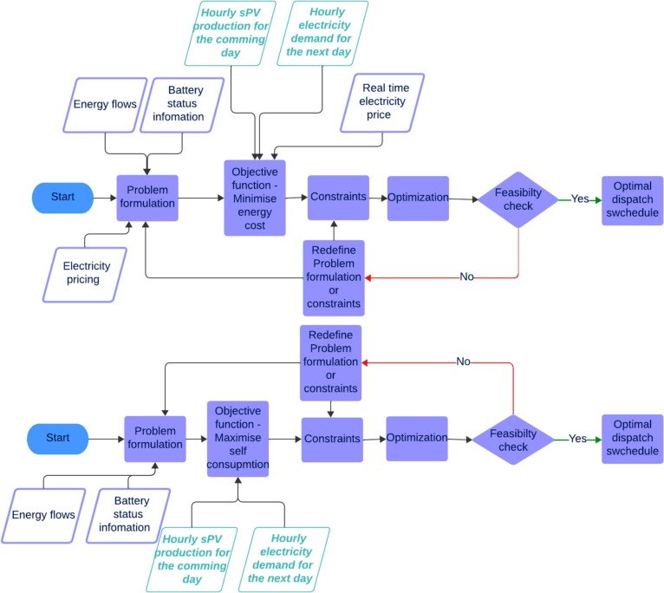
- Download: Download high-res image (411KB)
- Download: Download full-size image
Fig. 3. Algorithm describing the main processes, data inputs and decisions in the optimization model (purple) also showing the forecasted input from the ANN model (green). (For interpretation of the references to colour in this figure legend, the reader is referred to the web version of this article.)
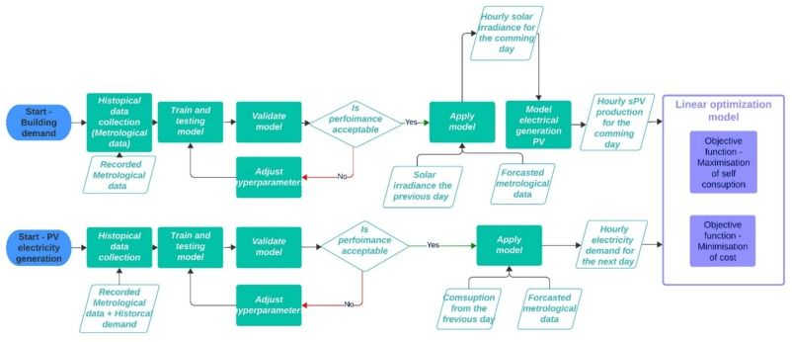
- Download: Download high-res image (293KB)
- Download: Download full-size image
Fig. 4. Algorithm describing the main processes, data inputs and decisions in the forecasting model.
To evaluate the accuracy of the model the following performance metrics are used: Normalized Mean Absolute Error (nMAE), Normalized Mean Squared Error (nMSE), Normalized Root Mean Squared Error nRMSE, and R-squared (R2). Where: nMAE, nMSE and nRMSE are all indicators of error in the model and low values of these metrics indicates a well performing model. R-squared on the other hand evaluates the proportion of variance in the target variable that the model explains. If R2 = 0 this means the model shows no correlation to the target variable, whereas R2 = 1 displays a perfect match. [26] [28] [29].

2.2.1. Forecasting of PV generation

2.2.1.1. Data collection and preprocessing
To generate a forecasting model for PV generation, the first step is to forecast solar irradiance. To achieve this meteorological data was gathered from the Swedish metrological and hydrological institute (SMHI) for the years 2021 and 2022 [30]. To make an accurate prediction the following data sets (extracted from the SMHI Open Data API) are considered: air temperature (°C), cloud coverage (0–8 scale), Global Horizontal Irradiance (GHI) in W/m^2, precipitation intensity (mm/h), relative humidity (%), and wind speed (m/s). Given the annual periodicity of weather patterns, data spanning 2021 and 2022 was utilized for robust model training and validation. Additionally, GHI values were obtained through the STRÅNG model, providing detailed solar radiation data [31].
To enhance the model's performance, its ability to learn patterns and make accurate predictions of solar irradiance, the zenith angle is to be calculated. It is crucial to understand the solar zenith angle to predict the sun's position in the sky and what effects this has for solar irradiance [32].Additional features, including the hour of the day, month of the year, and GHI of the preceding day, were incorporated to improve prediction accuracy of the model. These features, alongside the model's input dataset obtained from the SMHI Open Data API [33].

2.2.1.2. Relation between input and output data
An essential aspect of developing an effective ANN model lies in understanding the influence of each feature on the target value. Not all features are equally significant; some may even be irrelevant or redundant. Thus, comprehending this relationship between input and output is crucial for deriving insights from the data.
Fig. 5 (a) illustrates the feature scores, and their variations based on the number of selected features (k). Notably, the solar zenith angle and the GHI of the preceding day emerge as the most crucial features for predicting the day ahead GHI values, as anticipated. Whereas features such as precipitation intensity, cloud cover, and wind speed showed to be of less importance. However, it was decided to retain them after assessing model performance with and without these features, as they contributed to improved model accuracy [26].
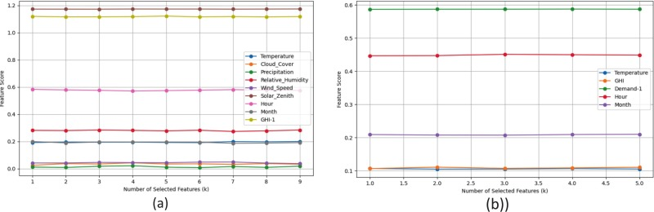
- Download: Download high-res image (240KB)
- Download: Download full-size image
Fig. 5. (a) Feature scores in relation to the solar irradiance (b)Feature scores in relation to the load prediction.[26]

2.2.1.3. Calculating the PV generation from the forecasted solar irradiation
The forecasted meteorological values are fed into a representative model of the PV generation that been developed in previous studies at the royal institute of technology (KTH) [22]. In addition to the forecasted values, the model requires several calculated parameters, namely the solar zenith angle, Direct Normal Irradiance (DNI), and Diffuse Horizontal Irradiance (DHI). Calculating the solar zenith angle is essential for the model's improved performance in learning patterns and accurately predicting solar irradiance. Understanding this angle helps anticipate the sun's position in the sky and its impact on solar irradiance. This information is then fed into the PV model, to calculate the PV production.

2.2.2. Forecasting of building demand

2.2.2.1. Data collection and preprocessing
To forecast the building's electricity consumption, meteorological data from SMHI was again used. By integrating weather dependent variables into the model, it improves at finding the correlations between meteorological conditions and energy consumption. Thereby. it enhances the precision and reliability of electricity demand forecasts. Temperature data played a particularly key role due to its significant impact on power demand. Fluctuations in temperature directly influence heating and cooling demands, consequently affecting energy usage. In addition to temperature, solar radiation was incorporated as a feature in the model, as it also reflects weather conditions and aids in understanding seasonal variations. The same dataset utilized for the solar irradiance forecasting model was employed.
To ensure effective training, recorded data of the building's electricity demand, obtained from the building's meters, was included as a feature. Like previous steps, this data underwent analysis to eliminate outliers. Additionally, features such as the hour of the day and the month of the year were considered in this model. Furthermore, incorporating demand from the preceding week bolstered the model's performance.

2.2.2.2. Relation between input and output data
As previously done for the PV modeling, the relationship between input and output values was analyzed, as shown in Fig. 5(b) which displays the feature scores relative to electricity demand. The demand from the previous day of the week and the hour of the day shows the highest scores. Whereas meteorological data such as temperature and GHI receive lower scores. Despite their lower scores, these features were retained for model development as they contributed to better results.

2.2.3. Battery aging
To enable holistic comparison between the different scenarios, it is crucial to see how each dispatch schedule will impact the aging of the BESS. Battery aging is the gradual deterioration of the performance of the battery. In this study, an empirical aging model was deployed to calculate calendric aging (the battery's aging over time) and cycling aging (the battery's aging due to charge and discharge cycles) caused by each of the dispatch strategies. The aging of the battery impacts the capacity, internal resistance, and overall lifespan. Therefore, two key indicators of battery aging are Direct Current Internal Resistance (DCIR) rise and loss of capacity.
As the battery ages, there is an increase in DCIR due to the formation and growth of the solid electrolyte interphase (SEI) layer, degradation of electrode materials, and accumulation of reaction biproducts. This increase in internal resistance leads to energy losses and increased heat development when charging and discharging the cells. Which in turn results in lower efficiency and power throughput. As the resistive losses generate heat, this can lead to an increased cell temperature, which can accelerate the aging of the battery. Loss of capacity on the other hand refers to the batteries lowered capability to hold charge. Over the battery's life, the active materials in the cell's electrolyte degrade which reduces the battery's ability to store and deliver energy. Both loss of capacity and increased DCIR occurs as a consequence of the cyclic and calendric aging of the battery. [34,35]´.
In this study an empirical aging developed by Northvolt for their NMC chemistry is deployed to simulate calendric and cyclic aging based on input parameters, resting SOC, time under rest, current and total cycled energy. As the aging ins based on models based on industrial cells all values in the result are normalized and discussed in relation to each other and the lifetime of the solar installation.

2.2.3.1. Cyclic aging
Cyclic degradation of batteries is the gradual deterioration of the performance of the battery due to repeated charge and discharge cycles. Factors that influence this type of battery degradation are temperature, current rate, and depth of discharge. [36] Cyclic aging in lithium-ion batteries primarily arises from the degradation of the solid electrolyte interphase (SEI) on the negative electrode and the loss of active materials in both electrodes. High temperatures accelerate these processes, leading to capacity loss and increased cell impedance. [35]
Cyclic aging is expressed in formula (14), where the increase in DCIR and decrease in capacity are calculated as a function of the total capacity throughput cycled over time. This model is based on empirical measurements performed on Li-Ion. The cells were cycled in lab environment in predefined current and temperatures. The aging curves of the cells were then mapped and the function in formula 15 is fitted to the curve. The first parameter that is extracted is the shape factor (P) which describes the general decay rate of the cell independent of operating conditions. However, as the operating conditions accelerate the aging parameters, Degradation Coefficient (D_cyc) is extrapolated to account for different combinations of temperature, current and SOC profiles.(14)
To define the parameters for each of the modeled dispatch schedules the current and temperature need to be calculated. The current is calculated based on the power and terminal voltage the system cooling system and room ventilation is dimensioned to keep the system temperature at an operating temperature between 25 and 30 Cº the nearest temperature in the tested index is 26Cº and was chosen as the default temperature for all scenarios.

2.2.3.2. Calendric aging
Calendric aging refers to the gradual degradation of the performance when the battery is resting. The aging that occurs during resting for the different scenarios is calculated using formula 15. Here the key factors are the cell SOC and the temperature. The same assumption for system temperature was made as for the cyclic aging.(15)
As the data provided regarding cell aging is sensitive information for the project partners all data regarding aging and cost will be presented in a normalized fashion. The normalization is displayed as a percentage of the best performance. Here the best scenario is presented as 100 % and the other values fall proportional under it. This normalization method is displayed in formula (16).(16)

2.2.4. Economical performance
Once the age of each profile has been analyzed a financial comparison between the different scenarios can be made. The parameters considered for the financial analysis are:
Variables | Representation | Unit
Initial investment cost | C_{int} | SEK
Cost for replacement of components | C_{repl} | SEK
Lifetime replacement component | LT_{comp} | h
Lifetime of installation | LTe_{inst} | h
Inflation | Inf | %
Total energy throughput | E_{throughput} | kWh
Yearly financial return | R_{year} | SEK
Once the total lifetime cost has been calculated the levelized cost of storage (LCOS) can be calculated.(17)
Robust Optimization Framework for Uncertainty Management
In order to deal with the impacts of uncertainties associated with demand and PV generation predictions optimal battery scheduling, a robust optimization framework has been considered [37]. The robust optimization framework ensures optimal battery scheduling even under the worst-case scenarios by incorporating a box uncertainty set [38]. In this framework, uncertain parameters, such as demand (
) and solar generation ( ), are modeled within predefined ranges around their forecasted values ( and ) that and .
are the maximum deviations from the forecasts from actual values based on historical data.
The optimization problem is then reformulated to ensure that constraints hold for all possible values within these uncertainty sets. This is achieved by transforming the original constraints to their robust equivalents, effectively linearizing the problem while considering the worst-case deviations. Consequently, the robust optimization model guarantees feasible and reliable battery scheduling decisions, mitigating the risks associated with prediction errors in demand and solar generation.

3. Results

3.1. Forecasting models
When configuring an artificial neural network (ANN), selecting the ideal hyperparameters is important for the model's predictive performance. As mentioned in the method section, a Grid Search approach is employed to systematically explore a range of configurations, such as the number of hidden layers, the number of neurons in each layer, and the learning rate. This show that an ANN with three hidden layers containing 18 neurons and a learning rate of 0.01 outperformed other configurations for predicting PV generations. This optimal set of hyperparameters is identified after evaluating various combinations. This suggests a balanced model complexity that can capture the underlying data patterns without overfitting or underperforming due to the simple model structure. A visualization of the setting of this MLP model can be found in Fig. 6a.
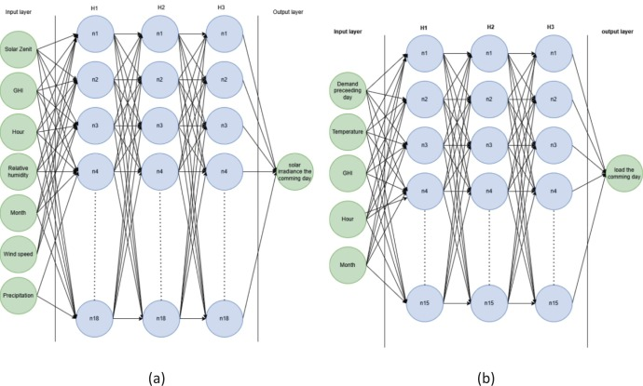
- Download: Download high-res image (405KB)
- Download: Download full-size image
Fig. 6. Settings of MLP model for solar irradiation (a) and load predictions (b).
This model exhibited robust performance in forecasting solar irradiance, which was confirmed by the low error metrics: nMAE in range of 0.03–0.09, nMSE of 0.01–0.02, and nRMSE of 0.08–0,14. Moreover, the high R² value of 0.8 confirmed that the model could capture a wide range of data variability, reinforcing its potential for PV forecasting in different seasons.
The simulated results for the PV generation are presented in Fig. 7 for February and August 2022. To better understand the daily behaviors, the month has been expressed as an average day, showing the average value in the opaque line, and the shaded area shows the variation in data over the month.
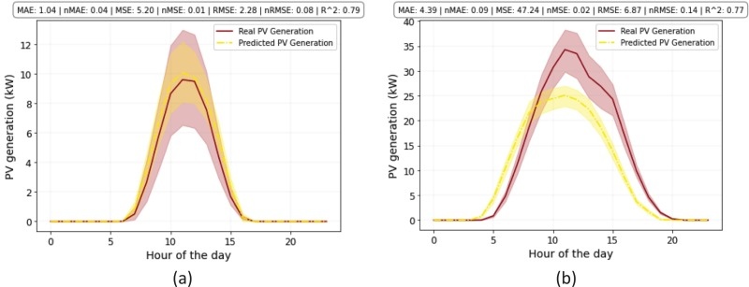
- Download: Download high-res image (245KB)
- Download: Download full-size image
Fig. 7. Real compared to predicted PV generation in (a) February 2022 and (b) August 2022.
Grid Search approach showed that for forecasting the load profile in the building, an ANN model consisting of 3 hidden layers each consisting of 15 nodes showed the highest performance. Generating a result with the following error metrics: nMAE = 0.06–0.08, nMSE = 0.01, and nRMSE = 0.08–0.12. For the load forecasting there are slightly elevated values, especially in nMSE. R-squared was in the range of R² = 0.28 to 0.663 meaning that there are variabilities in the data that the model is not able to predict. A visualization of the setting of this MLP model can be found in Fig. 6a and the simulated result for the building load profile can be found in Fig. 7 for February and August.
One reason for the load forecasting showing less robust results is that the input for the model is based on historical data from the people living in the building and their day-to-day electricity consumption. Since daily consumption varies depending on individual behavior, it introduces anomalies that are hard to capture. Anomalies like these highlight the importance of integrating active control, which adapts the charge and discharge patterns based on the surrounding meter values.

3.2. Optimal scenarios
Optimal results for four different scenarios with respect to Optimal results for four different scenarios with respect to the four scenarios for the year 2022 are presented in Table 9. Comparatively, the ‘Base case’ scenario served as a benchmark with a cost of 210,078, SEK/year and a self-consumption of 72 %. When BESS was integrated without considering monthly peak power charges (‘No Power Effect’), there was a substantial cost reduction of approximately 32 %, paired with a considerable increase in self-consumption to 96 %.
Table 9. Yearly results in cost and self-consumption for the different scenarios compared to the base case (without a battery).
Scenario | Cost (SEK) | Self-consumption (%)
Base case | 210,078 | 72
Power effect | 180,842 | 96
No power effect | 143,278 | 98
Self-Consumption | 204,787 | 100.00
Considering power charges in the ‘Power Effect’ scenario led to a cost 14 % lower than the base case but 26 % higher than the ‘No Power Effect’ scenario. The self-consumption rate for the ‘Power Effect’ scenario was slightly improved by 2 % over the ‘No Power Effect’ scenario. The ‘Self Consumption’ scenario achieved a self-consumption rate of 100 %, and this came at a cost that was 02.5 % lower than the base case. This scenario demonstrates the premium for total self-energy consumption, with costs reflecting a minor decrease over the foundational scenario without BESS.
Quantitatively, these findings illustrate the economic and efficient impacts of integrating BESS into PV systems. They emphasize a clear cost versus self-consumption trade-off, where the path to complete self-sufficiency is the costliest, yet the integration of BESS without power costs consideration offers substantial savings with high self-consumption.
To gain a comprehensive view of system performance throughout the year, this study presents the results of dispatch schedule optimization for photovoltaic (PV) systems coupled with battery energy storage systems (BESS) during February and August 2022. These months are chosen for their typical representation of winter and summer conditions. When analyzing the four scenarios, different patterns are observed in achieving the dual objectives of minimizing operational costs and enhancing the self-consumption of PV-generated electricity.

3.2.1. Winter season (lower solar radiation, higher electricity price)
Fig. 8 illustrates the optimization results for February 2022. The base case (no battery scenario) shows 28 % and 8 % higher operation cost than second and third scenarios, where BESS is integrated with PV system. However, the operation cost in the first and fourth scenarios are almost similar, because the fourth scenario ignored BESS almost 99 % of the time in February 2022 to achieve 100 % self-consumption. From self-consumption point of view, all four scenarios show comparable results (∼100 %). Comparing second and third scenarios shows the impact of considering power effects on operation cost. It shows that the power effect leads to a 21 % increase in operation cost.
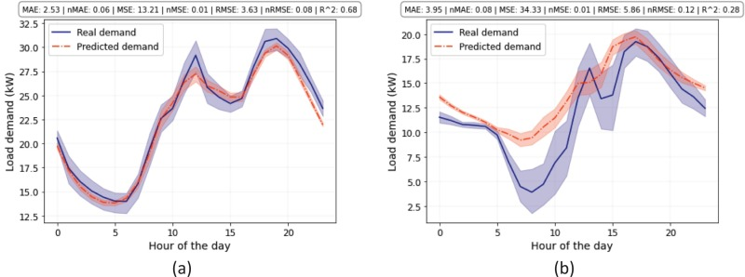
- Download: Download high-res image (275KB)
- Download: Download full-size image
Fig. 8. Real compared to predicted load in (a) February 2022 and (b) August 2022.
Fig. 9 depicts the operational cost components for four scenarios. Scenarios one and four do not incorporate battery storage, resulting in identical costs for electricity trading and grid costs. Due to the absence of battery storage and lower PV production than the demand, neither scenario yields any electricity export. The second scenario demonstrates some electricity being exported to the grid. Interestingly, despite the inclusion of battery storage in the third scenario, there is no electricity export. This highlights the influence of power effects on the cost structure and the resulting impact on the quantity of electricity stored and exported.
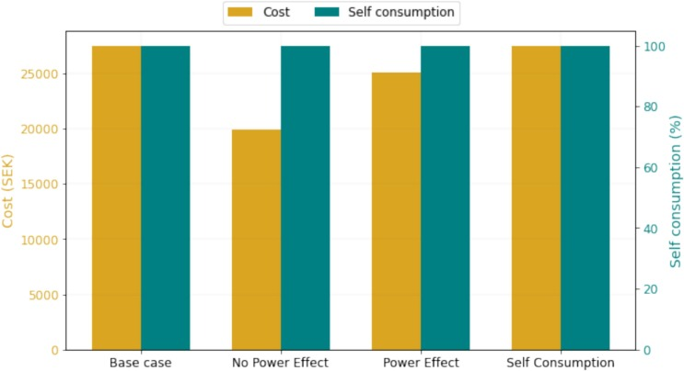
- Download: Download high-res image (164KB)
- Download: Download full-size image
Fig. 9. Optimization results for four scenarios in February 2022.
Fig. 10 illustrates an insightful comparison of the system's performance across four scenarios, covering three days (14th to 16th February) and exploring the interplay between the PV, battery, grid, and building. Scenarios one and four (Fig. 10a and d) display nearly identical daily patterns. The slight variance arises because, in scenario one, there is no optimization—grid usage is determined simply by subtracting PV production from the demand load. In scenario four, optimization rarely employs the battery, using it in exceptional cases for up to 2 kW, which insignificantly changes the overall outcome. In these two scenarios, any available PV electricity directly meets part of the demand, with the grid supplying the remaining demand load, regardless of the price of electricity.
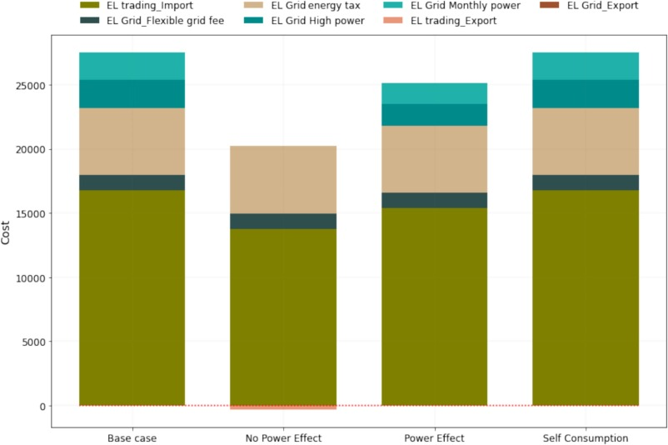
- Download: Download high-res image (210KB)
- Download: Download full-size image
Fig. 10. Cost breakdown for four scenarios in February 2022.
Conversely, scenario two (illustrated in Fig. 10b), which lacks a power penalty, strategically uses grid electricity to meet demand and charges the battery to its full capacity of 100 kW during low electricity prices. The system utilizes the stored battery power at high prices to meet the demand. However, the third scenario introduces power penalties (illustrated in Fig. 10c), leading to more conservative battery charging to avoid these additional costs. This results in less stored energy and, consequently, an increased reliance on importing electricity during the day.

3.2.2. Summer season (higher solar radiation, lower electricity price)
August 2022 has been selected as the representative of the summer season. In August 2022, a similar pattern in terms of operational costs is observed. The base case shows 48 % and 30 % higher operation cost than second and third scenarios respectively, where BESS is integrated with PV system. However, in August, self-consumption scenario has 6 % higher operation cost than the base case scenario. The operational costs for all cases are in the range of 4000 to 8000 SEK/month, which is lower when compared to February. Fig. 11 illustrates the optimization results for August 2022.
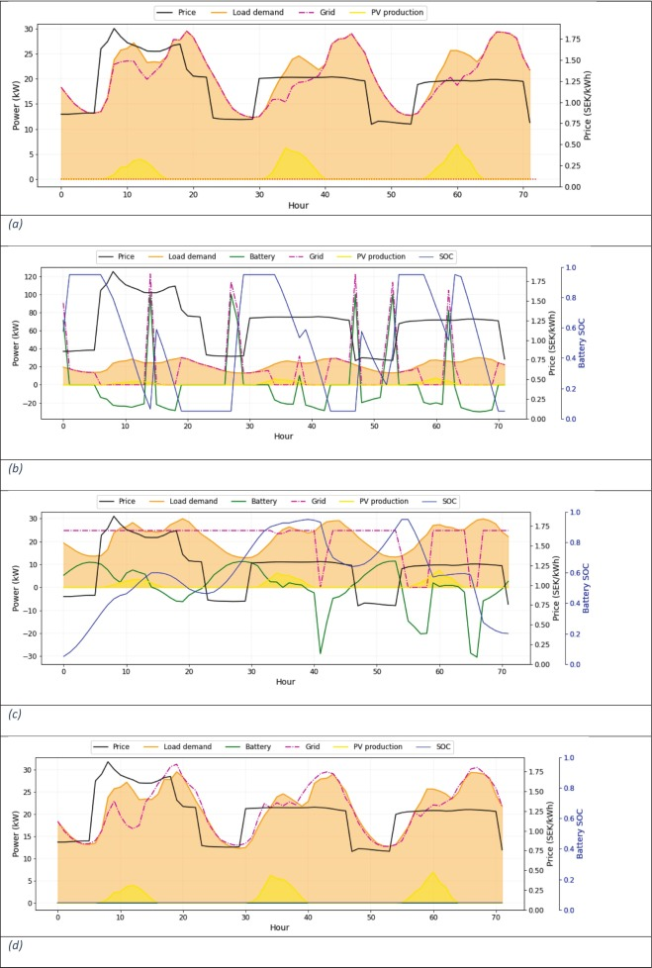
- Download: Download high-res image (718KB)
- Download: Download full-size image
Fig. 11. Detailed representation of system behavior in (a) No battery scenario, (b) No Power effect scenario, (c) Power effect scenario, and (d) self-consumption for February 2022.
From the perspective of self-consumption, the trends across scenarios one to four exhibit varying levels, at 60 %, 90 %, 97 %, and 100 %, respectively. This variation suggests that during the summer, with higher solar availability, the impact of the BESS on self-consumption becomes more pronounced.
Fig. 12 indicates that, due to the abundance of solar energy in August compared to February, electricity is exported in all scenarios. The base case scenario exports surplus electricity to the grid during the day but must import electricity when solar energy is unavailable. Consequently, this scenario has the highest electricity trading costs of all. Despite being second-best in terms of electricity exportation, the higher total cost arises from importing electricity when prices are high.
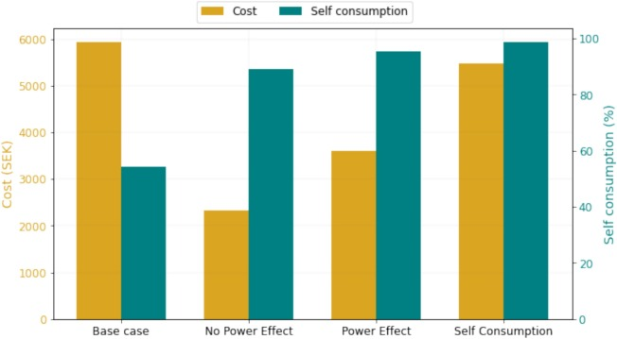
- Download: Download high-res image (140KB)
- Download: Download full-size image
Fig. 12. Optimization results for four scenarios in August 2022.
The second scenario, without any power limitations, effectively charges the battery when electricity is cheapest and exports it when prices peak. This strategic operation yields the greatest financial return and results in the lowest overall costs.
In the third scenario, power limitations are in place, which reduces both the amount of electricity imported and exported. Finally, the fourth scenario is designed to maximize self-consumption. It imports a similar amount of electricity to the base case but exports less, as it prioritizes on-site use by sending energy back to the grid.
Fig. 13 illustrates the system's operations over three consecutive days in August, with electricity prices ranging from 0.8 to 1.2 SEK/kWh, which is lower than February's prices. Nonetheless, electricity pricing remains crucial in optimizing scenarios two and three (Fig. 14 b, d). In scenario two, the battery discharges and sells electricity to the grid when prices are high. Due to the absence of power constraints, the battery is fully charged at night when electricity is cheaper, preparing it to be exported during the day as needed. In scenario three, which includes power limitations, the system primarily uses PV electricity to charge the battery and relies on grid imports to meet demand.
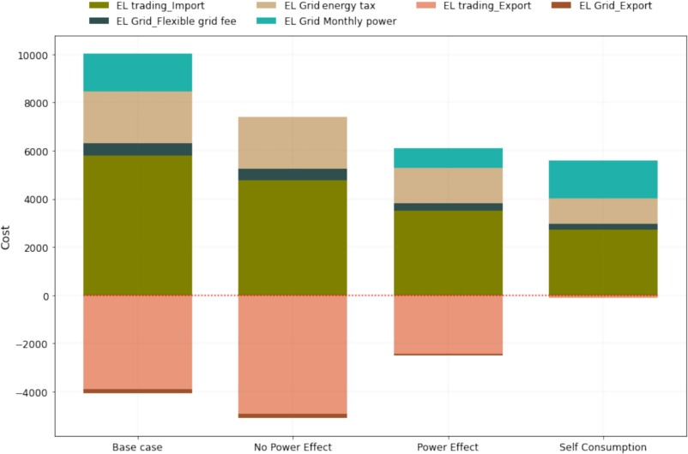
- Download: Download high-res image (205KB)
- Download: Download full-size image
Fig. 13. Cost breakdown for four scenarios in August 2022.
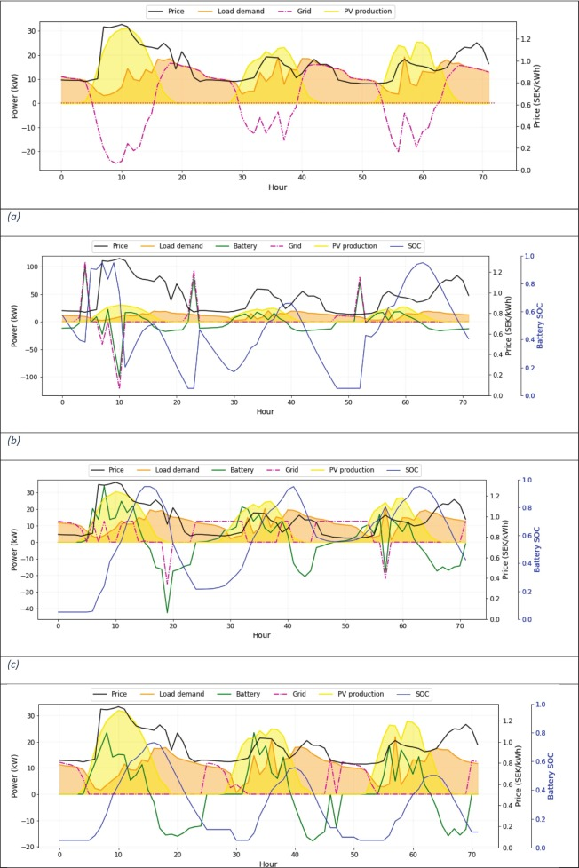
- Download: Download high-res image (770KB)
- Download: Download full-size image
Fig. 14. Detailed representation of system behavior in (a) No battery scenario, (b) No Power effect scenario, (c) Power effect scenario, and (d) self-consumption for August 2022Battery aging.
In contrast to February, where the first and fourth scenarios displayed similar trends, in August, they behave differently (Fig. 13-a and d). In the first scenario, excess PV production is exported, and electricity is imported when solar energy is unavailable, even at high prices. In the fourth scenario, available solar energy is used to meet demand and charge the battery, with no exports occurring. When solar energy is absent, the system utilizes stored battery energy to meet the demand and exports any surplus to the grid, regardless of the price.
To make a holistic comparison of the optimized dispatch strategies it is crucial to also consider the impact of system aging, as it impacts the lifetime of the system. These factors have an impact on the systems' techno economic performance. In this study, an empirical model is applied to analyze the fading capacity and increase in DCIR caused by the 3 different simulated scenarios. To calculate the aging caused by the different operation strategies of the system, the following information had to be extracted from the model: Capacity through put, average current (A), total hours the battery was resting, average resting SOC, and average cell temperature. The values for these parameters for each of the simulated dispatch strategies are found in Table 10.
Table 10. Extracted input parameters for aging model from each of the simulated dispatch strategies.
Empty Cell | No Power Opt. | Power Opt. | Self-consumption opt.
Capacity through put (kAh) | 100 % | 58 % | 17 %
Avg current (A) | 17 | 8 | 11
Total Hours at 0 power | 29 % | 5 % | 100 %
AVG resting SOC (%) | 41 | 39 | 10
AVG cell temperature (Cº) | 25 | 25 | 25
Fig. 15 displays the yearly relative capacity fade for each of the optimized dispatch strategies. By studying the impact of aging, it can be concluded that the highest impact on the loss in capacity for the system is caused by the optimization strategy that minimizes cost without considering the billing for monthly maximum power. This scenario has the highest capacity loss caused by cyclic aging which can be explained by it having the highest energy throughput and the higher currents related to the high-power charging and discharging. The scenario also has the second highest calendric aging, this can be explained by the increased periods of resting caused by the faster charger and discharge patterns.
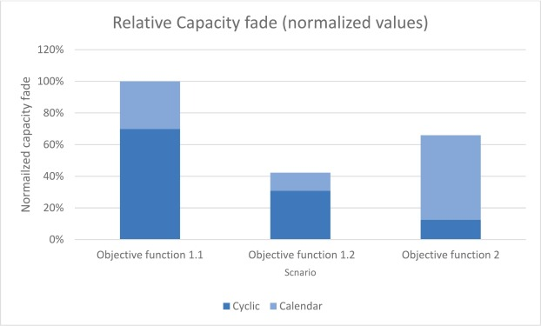
- Download: Download high-res image (151KB)
- Download: Download full-size image
Fig. 15. Relative capacity fade of the different scenarious based on the dispatch schedules generated gro the optimization stratergies. Displaying cyclic- (blue) and calendric (orange) capacity fade. (For interpretation of the references to colour in this figure legend, the reader is referred to the web version of this article.)
The second highest aging can be seen in the scenario that optimizes the self-consumption of generated PC electricity. For this scenario cyclic aging is the lowest of the three scenarios. This can be explained by the fact that the low amount of solar energy in the winter results in the battery resting more, and total cycled energy is the lowest for this scenario. However, long rest for the battery causes an increase in calendric aging and it is clearly visible that this scenario has the highest calendric aging.
The scenario that has the best performance in terms of aging is the scenario that optimizes towards the lowest cost but also considers the limitations caused by the power billing. This scenario has the lowest number of hours where the battery is resting, which leads to this approach having the lowest calendric aging of the three scenarios. It also has a lower cyclic aging compared to the scenario which does not consider any other power limitations than what is set from the capability of the inverter. This can be explained by two factors: first, the total amount of energy cycled in the first scenario is higher than in the second. Secondly, the system operates under lower power in the second scenario, leading to less cyclic aging.

3.3. Financial analysis
In order to make a further analysis of the degradation caused by the operation, an assumption was made that each the strategy would repeat yearly throughout the technical life of the PV system (25 years) [39]. The dispatch pattern was then run to see how the system aging would behave throughout the system's life. The result in cost savings and system longevity is presented in Table 11 and discussed in the following section.
Table 11. Aging extrapolation over the lifetime for a PV system.
Scenario | yearly cost reduction | Life cost reduction | Payback time [years] | Relative system lifetime | LCOS [SEK/kWh] | Net gain
Power effect | 66,800 | 1,681,500 | 14 | 31 % | 0.52 | 612,117
No power effect | 29,236 | 753,375 | 17.1 | 100 % | 0.45 | 239,442
Self-Consumption | 5291 | 132,275 | 101.8 | 90 % | 1.52 | −381,658
The strategy focusing on minimizing the hourly cost for the following day without taking power billing into account achieves significant yearly cost savings and operational cost reduction. This results in the highest net gain of SEK 612117. However, the strategy leads to full relative lifetime is only 31 % compared to the remaining scenarios despite increased aging, the LCOS remains reasonable at SEK 0.52/kWh. This operation strategy also shows the fastest return on investment of 14 years.
The strategy that targets minimizing monthly costs considering while considering the power limitations caused by the monthly power billing achieves moderate yearly cost. The payback time is 17.1 years longer. This operation strategy shows the best performance in terms of degradation. Where the relative lifetime is the highest and by far exceeds the lifetime of the PV system. Due to the system having a high capacity left, it would be possible to re-use or sell the system at EOL of the PV system. The LCOS is the lowest among the strategies at SEK 0.45/kWh, indicating high-cost efficiency. However, the net gain is lower than in what is observed when operating without considering power effects, making it less attractive from an economic standpoint, but more favorable in terms of system longevity.
The strategy which focuses on maximizing the self-consumption of solar-generated electricity leads to negative yearly cost savings and operational cost reduction, making it economically unviable. The negative payback time highlights that the strategy does not recover the initial investment, resulting in a substantial net loss of SEK 544,708. The LCOS is the highest at SEK 1.52/kWh, reflecting poor cost efficiency. Although the relative degradation is moderate, and the relative lifetime of the system is the second highest of 90 % compared to the best performing scenario but the strategy's overall financial impact is detrimental.

3.4. Evaluating the impact of robust optimization on battery scheduling under uncertainty
Table 12, Table 13 provide insights into electricity costs and self-consumption under deterministic and worst-case optimization scenarios, revealing how robust optimization handles uncertainties in demand and PV generation predictions. Table 12 shows the cost increase due to worst-case optimization is minimal for the base case (0.13 %) and when maximizing self-consumption of solar-generated electricity (0.07 %), indicating these scenarios are highly resilient to uncertainties. In contrast, minimizing hourly costs for the coming day (Objective Function 1.0) and minimizing monthly costs with real-time pricing (RTP) and power effect considerations (Objective Function 1.1) exhibit higher sensitivity, with cost increases of 1.10 % and 1.04 %, respectively. This suggests that cost minimization objectives are more affected by forecast inaccuracies in demand and PV generation.
Table 12. cost increase due to worst-case optimization.
Scenario | Cost (SEK) | Cost (SEK) | Difference due to uncertainty (%)
Empty Cell | Deterministic optimization | Worst-case optimization
Base case | 210,078 | 210,351 | 0,13
Power effect | 143,278 | 144,854 | 1,10
No power effect | 180,842 | 182,722 | 1,04
Self-Consumption | 204,787 | 204,930 | 0,07
Table 13. Self consumption decrease due to worst-case optimization.
Scenario | Self-consumption (%) | Self-consumption (%) | Difference due to uncertainty (%)
Empty Cell | Deterministic optimization | Worst-case optimization
Base case | 72 | 72,3 | 0,45
Power effect | 96 | 96,1 | 0,08
No power effect | 98 | 98, | 0,05
Self-Consumption | 100,00 | 99,91 | 0,09
Regarding self-consumption, as can be seen in Table 13, the increases are small. With the base case showing a 0.45 % increase and hourly cost minimization (Objective Function 1.0) showing a negligible increase of 0.08 %. Minimizing monthly costs (Objective Function 1.1) results in a slight decrease of 0.05 %, while maximizing self-consumption (Objective Function 2) shows a minimal decrease of 0.09 %, maintaining total solar energy utilization. These results highlight that while robust optimization slightly impacts cost, it ensures that self-consumption remains stable and efficient.

4. Discussion

4.1. Validation of the model
The validation of the model in the KTH Live-In Lab setting relies on integrating real-life data with the model's forecasting and optimization modules to align theoretical outcomes with actual building operations. To achieve practical relevance, the model was tested against real-time electricity pricing, meteorological data, and historical energy consumption patterns specific to Malvinas 14. The optimization framework, combining an ANN for predictive accuracy and a linear optimization module for dispatch scheduling, was designed to accommodate realistic energy demands and photovoltaic (PV) output, both of which were forecasted using historical data from the building and nearby weather stations.
To validate against the KTH Live-In Lab's operational patterns, the model's performance was assessed using error metrics (nMAE, nMSE, nRMSE, and R-squared) that indicate forecasting accuracy in PV generation and building load. Testing over distinct months, February and August 2022, demonstrated how well the model could adapt to seasonal variations, with February representing high-demand and low-solar periods and August as a high-solar period with lower electricity prices. The model's dispatch schedules are compared to a base scenario without battery integration to highlight cost savings, efficiency gains, and self-consumption rates. This setup proved effective in optimizing cost and self-consumption objectives and provided a robust framework adaptable to fluctuations in energy price and availability, validating its practical application in the KTH Live-In Lab setting.

4.2. Over all performances of the different scenarios
This study offers a comprehensive analysis of the performance of a grid-connected residential PV-BESS under various operational scenarios, emphasizing trade-offs between cost savings, self-consumption, and system longevity. The findings underscore the significant impact that different optimization strategies can have on the feasibility and financial performance of PV-BESS technology. The model developed in this study is designed for real-world implementation in the KTH Live-In Lab, utilizing real-time meter data and day-ahead pricing signals for electricity transactions. The primary objective is to demonstrate the resilience of the chosen forecasting model while also identifying optimal strategies for system operation on the following day. This forecasting-optimization framework is scalable and can be adapted for use with other PV-ESS systems in various types of buildings and urban environments. The model has a strong potential for application towards different regions in the country, as the forecasting of PV and load are based on historical data that can be retrieved from any place. The method can be reused for regions within the same country where the same billing structures and grid conditions are applicable - However, the forecasting model requires training with historical data specific to each case study.
Among the scenarios analyzed, the one that optimized minimizing hourly costs without considering power effect fees (Scenario 2) offered the highest net gain and quickest return on investment. However, this approach led to accelerated battery aging due to frequent high-power charging and discharging cycles. This rapid degradation significantly reduces the system's operational life, resulting in the need for battery replacements over the 25-year lifespan of the PV system. While financially attractive in the short term, this strategy may not be sustainable in the long term due to the higher costs associated with battery replacements.
The scenario that considered both cost and power effect fees (Scenario 3) demonstrated a more balanced performance. It provided moderate cost savings and extended the battery's operational life to align with the PV system's lifespan. This strategy results in the lowest Levelized Cost of Storage (LCOS), indicating high-cost efficiency. Although the payback period is longer, the extended battery life and potential for reuse or resale at the end of the system's life make this approach more sustainable and financially viable.
The scenario focused on maximizing self-consumption (Scenario 4) achieved 100 % self-consumption but proved to be economically unfeasible. The low net gain and the highest LCOS among the scenarios indicate that pursuing complete energy autonomy through PV-BESS systems may not be cost-effective. It needs to be highlighted however that the turbulent prices in the year 2022 decreased the relative financial gains related to self-consumption. However, even if a slight improvement in financial net gain could be achieved while studying another year, this study proves that solely focusing on self-consumption is too narrow a strategy which puts the investor at a higher risk.
When comparing the performance of the models in different seasons, the system behavior in February and August was studied. In February, the range of the electricity price spans between 0.75 and 2 SEK/kWh resulting in a price differential that is 1.25 SEK/kWh. During this time of year, the PV production is consistently low due to the few solar hours in the Nordics during winter months. Scenario 1 shows the battery system leveraging a broader price differential fully utilizing the SOC and completing 4 full charge and discharge cycles over the 3 days. The optimization strategy of the system encounters more pronounced challenges in Scenario 2, where slow charging rates due to billing limitations prevent the full exploitation of high-price periods. Finally, the strategy presented in scenario 3 results in the battery being completely inactive during the winter. In contrast, August presents a narrower price range of 0.4, and while the system continues to focus on fast charging and strategic discharging in Scenario 1., Scenario 2 performs better in these months compared to its performance in February. This is due to the access PV production enabling faster charging without increasing power consumption from the grid. It can be concluded that due to the summer months having a lower monthly power cost as it impacted by the high load billing. This leads to the system allowing a higher power extraction from the grid increasing the efficiency of the system. In Scenario 3, the presence of sufficient sunlight in August allows for more consistent charging of the battery with excess photovoltaic energy, enabling better alignment with evening demand. The financial analysis emphasizes the critical role that seasonal power billing plays in determining the financial feasibility of PV-BESS investments. In scenarios where rapid charging is limited by power billing (such as in the Power Effect, scenario 2), the system's ability to optimize cost savings is significantly hampered. This is particularly evident during winter months when solar generation is lower, and the system's reliance on grid electricity increases. The inflexibility imposed by seasonal power billing reduces the economic benefits of BESS integration.

4.3. Analysis of robust optimization on battery scheduling
The result from the analysis highlights the impact of robust optimization on electricity cost and self-consumption under uncertainty in demand and photovoltaic (PV) generation. By comparing deterministic and worst-case optimization scenarios, the results provide key insights into the resilience of various objective functions to forecast inaccuracies.

4.3.1. Cost sensitivity to uncertainty
Table 12 illustrates that the cost increases due to worst-case optimization are minimal for scenario 4 that maximizes self-consumption 0.07 %). This suggests that this scenario strategies is highly resilient to uncertainties in PV generation and load forecasts. However, optimization strategies that focus on cost minimization are more sensitive to uncertainties. The increase in electricity costs is higher for minimizing costs without considering peak power billing (scenario 2) at 1.10 % and minimizing costs without considering peak power billing (scenario 3) at 1.04 %. This implies that when optimization objectives emphasize immediate cost reductions, uncertainties in forecasts can lead to higher deviations, thereby affecting the financial efficiency of scheduling decisions.

4.3.2. Self-consumption stability under uncertainty
As shown in Table 13, the variations in self-consumption under worst-case optimization remain marginal, emphasizing the robustness of the system in maintaining efficient utilization of solar-generated electricity. Scenario 2 results in an insignificant increase of 0.08 %. Conversely, scenario 3 and Scenario 4exhibit slight reductions of 0.05 % and 0.09 %, respectively.
These results suggest that uncertainties in prediction do not significantly impact self-consumption rates. The system remains highly effective in utilizing available solar energy, reinforcing the idea that robust optimization strategies ensure operational stability while only marginally affecting performance metrics.

4.3.3. Implications for battery scheduling strategies
The findings indicate that robust optimization provides a trade-off between cost efficiency and system resilience. For decision-makers prioritizing cost minimization, the increased sensitivity to uncertainty necessitates accurate forecasting and potential contingency measures to mitigate cost fluctuations. In contrast, strategies focused on self-consumption and operational stability exhibit greater robustness to forecast deviations, ensuring consistent utilization of solar resources.
These insights are relevant for energy management systems that must operate under dynamic conditions, such as real-time electricity pricing and fluctuating renewable energy generation. The ability of robust optimization to maintain cost effectiveness while preserving self-consumption stability makes it a valuable tool for enhancing battery scheduling performance in uncertain environments Future research should also focus on the combination of forecasting paired with anomaly detection and control.In summary, the optimal approach to PV-BESS investment depends on balancing short-term financial gains with long-term sustainability. For investors and policymakers, the findings suggest that the integration of BESS into PV systems is most feasible when operational strategies are aligned with flexible energy management schemes, including the use of day-ahead forecasting and RTP. However, the future markets of energy are adapting towards higher flexibility with real-time pricing on an hourly basis. The power billing structures require further analysis of the impact of their increased flexibility rather than rigid seasonal and monthly billing models. This as the conversion into a renewable and intermittent energy system requires fast responding and financially viable ESS to be technically possible. Further investigation into how power billing could also align with could aid the introduction of more ESS into urban society and thus increase the possibility for a higher penetration of roof top PV while also aiding in balancing the grid. Future studies would also benefit from including aging as a variable in linear optimization to enable dispatch strategies that also consider the cost of aging the battery.

4.4. Comparison to previous work
A review of previous studies using similar approaches shows a clear consensus: PV-BESS integration has strong potential to reduce electricity costs, enhance self-consumption, and support grid flexibility. Additionally, advanced optimization methods—such as Model Predictive Control (MPC), Deep Reinforcement Learning (DRL), and neural networks—can significantly improve the economic and environmental benefits of these systems. [15] [12] [11] Many of these energy management frameworks are highly scalable across different building types and climates. Data-driven neural networks can recognize patterns and adapt to new sites, making them especially effective. This study further validates that such models are feasible for real-world applications, as demonstrated through their successful implementation in the KTH Live-In Lab.
In the U.S., much of the discussion around PV-BESS integration focuses on net metering (NEM), which incentivizes the export of excess solar energy to the grid. As a result, NEM has historically reduced the financial viability of BESS in these scenarios. [9] However, many studies now explore use cases that exclude NEM, as it is being phased out in several American states. These studies highlight that, without NEM, selling PV-generated electricity becomes less profitable, thereby strengthening the business case for BESS. [10] [12] Shifting away from the current billing structure and adopting Time-of-Use (TOU) or Real-Time Electricity (RTE) pricing—without NEM—can create stronger financial incentives for PV-BESS integration. Since this study was conducted and validated in Sweden, where NEM policies are not in place and electricity pricing follows an RTE scheme, it further demonstrates that investing in BESS can be highly profitable in markets with flexible electricity pricing and energy generation.
In summary, the KTH Live-In Lab study aligns with existing research in demonstrating the economic and environmental benefits of optimized PV-BESS dispatch, particularly under real-time pricing. However, its real-world validation, multy-household focus, and ANN-based computational efficiency differentiate it from simulation-based studies, large-scale energy-sharing models, and deep-learning-driven optimization frameworks. The key deviations arise from variations in system configurations (PV-BESS-only vs. hybrid systems), optimization methods (ANN vs. DRL), and research scope (individual households vs. multi-building or policy-driven approaches).

4.5. Implications on policy changes
The results identify potential adaptations can significantly impact the integration of PV-ESS systems into the residential market. One large limitation for making PV-ESS financially optimal is the ridged structure of the peak power billing and power tariffs. Therefore, implementing a flexible power tariff scheme would allow battery energy storage systems (BESS) to respond more quickly to market fluctuations, thereby enhancing their regulatory capabilities. Additionally, a flexible tariff structure would improve the financial feasibility of PV-ESS, making renewable energy more attractive. However, these more aggressive operational strategies could lead to faster system degradation. Therefore, further research is needed to determine the optimal balance between market gains and system longevity.
Another highlighted limitation of the adaptation of PV-ESS is the investment cost of the BESS. Thus, increasing the adoption of dispatchable renewable energy sources, such as PV-ESS, can be facilitated through subsidies for residential battery storage. While the cost of photovoltaic (PV) systems has decreased significantly, making them financially viable with a fast return on investment (ROI), battery costs remain high, especially for smaller capacities. Historical trends show that subsidies for PV systems have successfully expanded the market, and similar incentives for BESS could yield comparable results.
In the sensitivity analysis it is highlighted that the more cost drive optimizations have a higher sensitivity to price variations. One way to improve the robustness of the price offer is to enable smaller systems to participate in multiple energy markets. This would require further research into multi-market optimization for the residential sector. By allowing PV-ESS owners to engage in various energy trading platforms, price stability improves, further strengthening the case for distributed PV-ESS in urban areas.

4.6. Limitations and future research
This study has several limitations that are to be acknowledged. The study is conducted in Sweden, a country with high grid stability. This makes it less representative of regions with less stable grids where grid stability needs to be considered as an optimization parameter or limitation.
In addition, the focus of this paper is restricted to cost optimization through spot price arbitrage and the Swedish billing structures, which narrows its scope and excludes broader optimization opportunities. The Artificial Neural Network (ANN) used in this study relies on a substantial dataset for training and validation, meaning its accuracy could be compromised when deployed at new sites with limited or no historical data. Finally, the load prediction was based solely on apartment user consumption, excluding the heating-related electricity demand. As the heat pumps for the area are located in separate buildings, a more comprehensive prediction, particularly in cases where electricity demand is influenced by weather conditions, could have been achieved by incorporating heating needs into the model.
To address these limitations and advance the field, future research should focus on several directions. Expanding models to balance multiple markets simultaneously could enhance grid stability, return on investment and operational efficiency. Incorporating battery aging as a variable in optimization models would better account for long-term cost and performance implications. Testing the proposed model in diverse international settings is essential to identify necessary adjustments for different cost structures, regulatory frameworks, and grid stability conditions. Additionally, developing live control algorithms capable of detecting anomalies in forecasts and adapting operational strategies in real time would improve model resilience and performance under dynamic and uncertain conditions.

5. Conclusion
This study investigates the optimization of battery operations to maximize self-consumption and minimize costs through linear optimization coupled with day ahead forecasting. Two interconnected modules are key in the model: one for linear optimization towards three objective functions related to cost and self-consumption, and the other for accurate forecasting of building demand and PV generation using an ANN framework. The integration of the model successfully aligned with the operational patterns of the KTH Live-In Lab, demonstrating its readiness for real-world application. By utilizing actual meteorological, pricing, and historical demand data, the model produced optimized dispatch schedules that effectively balanced cost savings and self-consumption goals. Seasonal testing in February and August showcased the model's adaptability, with notable performance improvements over the base case scenario, particularly in self-consumption and operational cost reduction. This validation underscores the model's potential as a practical tool for optimizing energy flows in dynamic residential environments, offering a scalable approach for broader sustainable energy management applications.
The model proved to be a robust tool to capture variability caused by seasonal and electricity trading variations. By integrating the tool into real life, setting conflicting billing structures where successfully identified. Highlighting a research gap regarding PV-ESS systems in the GCRS in larger residential actors in Sweden have a conflict in financial potential of the system caused by the difference in rigidness between energy Real-Time Pricing (RTP) and monthly power fees. The use of day ahead forecasting also lays the groundwork for optimized control to be implemented on the physical system at the KTH Live-in Lab.
The study's yearly results demonstrate considerable improvements in self-consumption and cost reduction compared to the base case (without a battery). This scenario had a yearly cost of 210,078 SEK in 2022 and a self-consumption of 72 %. When optimizing towards minimizing the electricity cost and not considering power effect fees (Scenario 2 – No power effect) the costs drop by 32 % and self-consumption increases significantly to 96 %. However, due to the more aggressive nature of charging and discharging of the BESS this is the only application where the battery due to aging needs replacement within the lifespan of the PV installation. When considering power effect fees (Scenario 3 – Power effect), the cost reduction is slightly lower at 21.9 % and self-consumption increases to 98 %. In the scenario of optimizing maximized self-consumption (Scenario 4 – Self consumption) the costs decrease by 3 % and 100 % self-consumption is achieved.
The sensitivity analysis of the study highlights the importance of selecting appropriate optimization objectives based on the desired balance between cost minimization and operational resilience. While robust optimization slightly increases electricity costs under worst-case scenarios, it ensures stable performance of battery scheduling, making it a viable approach for real-world applications. Future work could further explore how anomaly detection could be integrated into the live control of the system and rerun the forecasting model to set a new strategy once the system is operational.
In summary, the optimal PV-BESS investment strategy balances short-term financial gains with long-term sustainability. The findings suggest that integrating BESS with PV systems is most effective when operational strategies align with flexible energy management, such as day-ahead forecasting and real-time pricing (RTP). As energy markets shift towards hourly RTP, power billing structures need further analysis to adapt to this flexibility. This adaptation is crucial for enabling the integration of renewable energy systems, which require fast-responding and financially viable energy storage solutions.

CRediT authorship contribution statement
Linda Lundmark: Writing – original draft, Conceptualization, Visualization, Resources, Formal analysis, Methodology, Validation, Investigation, Data curation. Farzin Golzar: Supervision, Formal analysis, Writing – original draft, Project administration, Conceptualization, Writing – review & editing, Software. Rafael Guedez: Writing – review & editing, Supervision, Conceptualization, Funding acquisition. Majid Astaneh: Methodology, Supervision, Writing – review & editing, Conceptualization.

Declaration of generative AI and AI-assisted technologies in the writing process
During the preparation of this work the author(s) used ChatGPT 4o in order to control grammar and improve readability. After using this tool/service, the author(s) reviewed and edited the content as needed and take(s) full responsibility for the content of the published article.

Declaration of competing interest
The authors declare the following financial interests/personal relationships which may be considered as potential competing interests: Linda Lundmark reports financial support, administrative support, and equipment, drugs, or supplies were provided by Northvolt AB. Linda Lundmark reports financial support was provided by Swedish Energy Agency. Linda Lundmark reports administrative support, statistical analysis, travel, and writing assistance were provided by KTH Royal Institute of Technology. Linda Lundmark reports financial support and equipment, drugs, or supplies were provided by Einar Mattson AB. Linda Lundmark reports a relationship with Northvolt AB that includes: employment. Majid Astaneh reports a relationship with Northvolt AB that includes: employment. Farzin Golzar reports a relationship with KTH Royal Institute of Technology that includes: employment. Rafael Guedez reports a relationship with KTH Royal Institute of Technology that includes: employment. The research project connected to this paper is funded by the Swedish Energy Agency. The project is led by KTH, Royal Institute of Technology, and partners of the project include Einar Mattsson AB and Northvolt AB. If there are other authors, they declare that they have no known competing financial interests or personal relationships that could have appeared to influence the work reported in this paper.

Data availability
Data will be made avaliable uppon request excluding data relted to cell aging which is confidential

References
- [1]
J. Gustavsson
On the limitations of current support mechanisms for solar electricity in Sweden: A quantification of lost opportunities of solar electricity as a consequence of the regulation for tax exemption being insufficiently designed
Accessed: Sep. 12, 2023. [Online]. Available:
https://urn.kb.se/resolve?urn=urn:nbn:se:kth:diva-246112
(2018)
Google Scholar
[3]
N. Blasuttigh, S. Negri, A. Massi Pavan, E. Tironi
Optimal sizing and environ-economic analysis of PV-BESS Systems for jointly acting renewable self-consumers
Energies, 16 (3) (Jan. 2023), Article 3, 10.3390/en16031244
Google Scholar
[4]
Minskad elanvändning och elproduktion under 2023
Accessed: Apr. 18, 2024. [Online]. Available:
https://www.energimyndigheten.se/nyhetsarkiv/2024/minskad-elanvandning-och-elproduktion-under-2023/
(2023)
Google Scholar
[5]
A.H. Schleifer, C.A. Murphy, W.J. Cole, P.L. Denholm
The evolving energy and capacity values of utility-scale PV-plus-battery hybrid system architectures
Adv Appl Energy, 2 (May 2021), Article 100015, 10.1016/j.adapen.2021.100015
View PDFView articleView in ScopusGoogle Scholar[6]
N.G. Chatzigeorgiou, S. Theocharides, G. Makrides, G.E. Georghiou
A review on battery energy storage systems: applications, developments, and research trends of hybrid installations in the end-user sector
J Energy Storage, 86 (May 2024), Article 111192, 10.1016/j.est.2024.111192
View PDFView articleView in ScopusGoogle Scholar[7]
R. Khezri, A. Mahmoudi, H. Aki
Optimal planning of solar photovoltaic and battery storage systems for grid-connected residential sector: review, challenges and new perspectives
Renew Sust Energ Rev, 153 (Jan. 2022), Article 111763, 10.1016/j.rser.2021.111763
View PDFView articleView in ScopusGoogle Scholar[8]
J. Despeghel, J. Tant, J. Driesen
Convex optimization of PV-battery system sizing and operation with non-linear loss models
Appl Energy, 353 (Jan. 2024), Article 121976, 10.1016/j.apenergy.2023.121976
View PDFView articleView in ScopusGoogle Scholar[9]
M. Wei, et al.
Approaches to cost-effective near-net zero energy new homes with time-of-use value of energy and battery storage
Adv Appl Energy, 2 (May 2021), Article 100018, 10.1016/j.adapen.2021.100018
View PDFView articleView in ScopusGoogle Scholar[10]
X. Chen, et al.
Multi-objective optimization of battery capacity of grid-connected PV-BESS system in hybrid building energy sharing community considering time-of-use tariff
Appl Energy, 350 (Nov. 2023), Article 121727, 10.1016/j.apenergy.2023.121727
View PDFView articleView in ScopusGoogle Scholar[11]
S. Yang, H.O. Gao, F. You
Integrated optimization in operations control and systems design for carbon emission reduction in building electrification with distributed energy resources
Adv Appl Energy, 12 (Dec. 2023), Article 100144, 10.1016/j.adapen.2023.100144
View PDFView articleView in ScopusGoogle Scholar[12]
S. Yang, H.O. Gao, F. You
Building electrification and carbon emissions: integrated energy management considering the dynamics of the electricity mix and pricing
Adv Appl Energy, 10 (Jun. 2023), Article 100141, 10.1016/j.adapen.2023.100141
View PDFView articleView in ScopusGoogle Scholar[13]
Rolling horizon optimization based real-time energy management of a residential neighborhood considering PV and ESS usage fairness - ScienceDirect
Accessed: Aug. 30, 2024. [Online]. Available:
https://www.sciencedirect.com/science/article/pii/S0306261923006396
(2024)
Google Scholar
[14]
Optimal Sizing of Grid-tied Residential Microgrids Under Real-Time Pricing | IEEE Conference Publication | IEEE Xplore
Accessed: Aug. 29, 2024. [Online]. Available:
https://ieeexplore.ieee.org/document/9595828
(2024)
Google Scholar
[15]
Q. Chen, Z. Kuang, X. Liu, T. Zhang
Application-oriented assessment of grid-connected PV-battery system with deep reinforcement learning in buildings considering electricity price dynamics
Appl Energy, 364 (Jun. 2024), Article 123163, 10.1016/j.apenergy.2024.123163
View PDFView articleView in ScopusGoogle Scholar[16]
Nord Pool | Day-ahead prices
Accessed: Apr. 30, 2024. [Online]. Available:
https://data.nordpoolgroup.com/auction/day-ahead/prices?deliveryDate=latest&currency=EUR&aggregation=Hourly&deliveryAreas=AT
(2024)
Google Scholar
[17]
A turnkey solution for Swedish buildings through integrated PV electricity and energy storage (PV-ESS), KTH (2023)
Accessed: Sep. 13, 2023. [Online]. Available:
https://www.energy.kth.se/heat-and-power-technology/current-projects/a-turnkey-solution-for-swedish-buildings-through-integrated-pv-electricity-and-energy-storage-pv-ess-1.1115805
Google Scholar
[18]
KTH - Sveriges största tekniska universitet, KTH (2024)
Accessed: Apr 29, 2024. [Online]. Available:
https://www.kth.se/
Google Scholar
[19]
Northvolt | Northvolt
Accessed: Apr. 29, 2024. [Online]. Available:
https://northvolt.com/
(2024)
Google Scholar
[20]
Einar Mattsson | Äger, förvaltar, utvecklar och bygger bostäder i Stockholm
Accessed: Apr. 29, 2024. [Online]. Available:
http://www.einarmattsson.se/
(2024)
Google Scholar
[21]
KTH live-in lab, KTH (2023)
Accessed: Sep. 13, 2023. [Online]. Available:
https://www.liveinlab.kth.se/start-1.1064463
Google Scholar
[22]
D. Chakraborty
A turnkey solution for Swedish buildings through integrated PV electricity and battery storage
Accessed: Dec. 01, 2023. [Online]. Available:
https://aaltodoc.aalto.fi/handle/123456789/119492
(Jan. 2023)
Google Scholar
[23]
2022 CAPEX
Tableau software
Accessed: Aug 13, 2024. [Online]. Available:
https://public.tableau.com/views/2022CAPEX/Inclusions?:embed=y&Technology=All,Commercial%20Battery%20Storage&Exclude%20Distributed=0&:embed=y&:showVizHome=n&:bootstrapWhenNotified=y&:apiID=handler2
(2024)
Google Scholar
[24]
Företag elnätspriser och avtalsvillkor | Vattenfall Eldistribution
Accessed: Apr. 19, 2024. [Online]. Available:
https://www.vattenfalleldistribution.se/kund-i-elnatet/elnatspriser/elnatspriser-och-avtalsvillkor-foretag/
(2024)
Google Scholar
[25]
S. Agatonovic-Kustrin, R. Beresford
Basic concepts of artificial neural network (ANN) modeling and its application in pharmaceutical research
J Pharm Biomed Anal, 22 (5) (Jun. 2000), pp. 717-727, 10.1016/S0731-7085(99)00272-1
View PDFView articleView in ScopusGoogle Scholar[26]
M. Flor Lopes
Forecasting and¨optimization models for integrated PV-ESS systems: : a case study at KTH live-in lab
Accessed: Apr 12, 2024. [Online]. Available:
https://urn.kb.se/resolve?urn=urn:nbn:se:kth:diva-339057
(2023)
Google Scholar
[27]
H. Ramchoun, M. Amine, J. Idrissi, Y. Ghanou, M. Ettaouil
Multilayer perceptron: architecture optimization and training
Int J Interact Multimed Artif Intel, 4 (Jan. 2016), pp. 26-30, 10.9781/ijimai.2016.415
Google Scholar
[28]
F. Sohil, M.U. Sohali, J. Shabbir
An introduction to statistical learning with applications in R: by Gareth James, Daniela Witten, Trevor Hastie, and Robert Tibshirani, New York, Springer Science and Business Media, 2013, $41.98, eISBN: 978-1-4614-7137-7
Stat Theory Relat Fields, 6 (1) (Jan. 2022), p. 87, 10.1080/24754269.2021.1980261
Google Scholar
[30]
Ladda ner meteorologiska observationer | SMHI
Accessed: Apr. 30, 2024. [Online]. Available:
https://www.smhi.se/data/meteorologi/ladda-ner-meteorologiska-observationer/#param=airtemperatureInstant,stations=core,stationid=97200
(2024)
Google Scholar
[31]
STRÅNG
Accessed: Apr. 29, 2024. [Online]. Available:
https://strang.smhi.se/
(2024)
Google Scholar
[32]
S.A. Fatemi, A. Kuh
Solar radiation forecasting using zenith angle
Presented at the 2013 IEEE Global Conference on Signal and Information Processing, GlobalSIP 2013 - Proceedings (Dec. 2013), pp. 523-526, 10.1109/GlobalSIP.2013.6736930
View in ScopusGoogle Scholar[33]
SMHI Open Data API Docs - Meteorological Forecasts
Accessed: Apr. 29, 2024. [Online]. Available:
https://opendata.smhi.se/apidocs/metfcst/index.html
(2024)
Google Scholar
[34]
G.K. Prasad, C.D. Rahn
Model based identification of aging parameters in lithium ion batteries
J Power Sources, 232 (Jun. 2013), pp. 79-85, 10.1016/j.jpowsour.2013.01.041
View PDFView articleView in ScopusGoogle Scholar[35]
M. Broussely, et al.
Main aging mechanisms in li ion batteries
J Power Sources, 146 (1) (Aug. 2005), pp. 90-96, 10.1016/j.jpowsour.2005.03.172
View PDFView articleView in ScopusGoogle Scholar[36]
G. Sarre, P. Blanchard, M. Broussely
Aging of lithium-ion batteries
J Power Sources, 127 (1) (Mar. 2004), pp. 65-71, 10.1016/j.jpowsour.2003.09.008
View PDFView articleView in ScopusGoogle Scholar[37]
V. Gabrel, C. Murat, A. Thiele
Recent advances in robust optimization: an overview
Eur J Oper Res, 235 (3) (Jun. 2014), pp. 471-483, 10.1016/j.ejor.2013.09.036
View PDFView articleView in ScopusGoogle Scholar[38]
A. Dehnokhalaji, S. Khezri, A. Emrouznejad
A box-uncertainty in DEA: a robust performance measurement framework
Expert Syst Appl, 187 (Jan. 2022), Article 115855, 10.1016/j.eswa.2021.115855
View PDFView articleView in ScopusGoogle Scholar[39]
V. Tan, P.R. Dias, N. Chang, R. Deng
Estimating the lifetime of solar photovoltaic modules in Australia
Sustainability, 14 (9) (Jan. 2022), Article 9, 10.3390/su14095336
View at publisherGoogle ScholarPrevious article in issue
Next article in issue
[2]
Energimyndighete (swedish energy agency)
Energiläget 2020 (Energy in Sweden) -ET 2020:1
(2020)
Google Scholar
[29]
S. Raschka, V. Mirjalili
Python machine learning: Machine learning and deep learning with Python, scikit-learn, and TensorFlow 2
(3rd ed.), Packt Publishing, Limited, Birmingham (2019)
Google Scholar

